Advisory Committee on
Assisted Reproductive Technology

Proposal that the HART Order should explicitly state that the use of cryopreserved testicular tissue
is an established procedure
Consultation document

Citation: Advisory Committee on Assisted Reproductive Technology. 2021. Proposal that the HART Order should explicitly state that the use of cryopreserved testicular tissue is an established procedure: Consultation document. Wellington: Advisory Committee on Assisted Reproductive Technology.
Published in May 2021 by the Advisory Committee on Assisted Reproductive Technology, PO Box 5013, Wellington 6140, New Zealand
ISBN 978-1-99-002984-4 (online)
HP 7599
This document is available on the ACART website:
www.acart.health.govt.nz

Contents
1 Introduction 1
Current status of the cryopreservation of testicular tissue and its use 1
ACART proposes the HART Order be amended 2
ACART’s definition of the use of CTT 2
2 The matters ACART has considered 4
Overview of the legal and ethical matters 4
Cultural considerations 4
Disability perspective 5
International practice 5
3 Proposed change to the HART Order 6
Proposal and rationale for change 6
4 How to have your say 7
Publication of feedback 7
Official Information Act requests 7
5 Feedback form 8
Question 1 9
Question 2 9
Glossary 10
References 12

Introduction

Current status of the cryopreservation of testicular tissue and its use
    - The Human Assisted Reproductive Technology Order 2005 (HART Order) was passed under the Human Assisted Reproductive Technology Act 2004 (HART Act). It lists fertility procedures that do not require approval from the Ethics Committee on Assisted Reproductive Technology (ECART) because they are ‘established procedures’ (EPs): procedures that are done routinely during the course of fertility treatment.
    - Cryopreserved testicular tissue (CTT) is frequently used in fertility treatment. However, the HART regulatory framework does not include any express description of the status of CTT and its use.
    - The retrieval of sperm from fresh testicular tissue is an EP, and the HART Order describes sperm cryopreservation as an EP. However, the procedures described under ‘sperm cryopreservation’ are not an exhaustive list. ACART also notes that neither ‘sperm’ nor ‘testicular tissue’ is defined in the HART legislation.
    - ACART understands that it is standard practice for clinics to extract sperm from thawed CTT, and that practitioners believe this is also an EP.
    - Because the HART Order does not explicitly cover the use of CTT, it needs to be amended to clarify the legality of the procedure.
    - ACART considered several factors before recommending amendments to the Order. These are outlined in the online document which sets out in detail its functions and the regulatory and ethical setting in which it operates.
    - Subject to this consultation, ACART proposes to make this recommendation according to its statutory role, prescribed in the HART Act, to make recommendations to the Minister of Health on the regulation of fertility services.

ACART proposes the HART Order be amended
    - New Zealand needs a regulatory framework that is logical and consistent. ACART proposes that the HART Order be amended to remove uncertainty by stating that the use of frozen then thawed testicular tissue, to obtain sperm, is an EP (provided the tissue was retrieved from live people with informed consent). The Order would be amended so that the regulatory setting for fertility treatment in New Zealand is as clear as possible.
    - ACART invites you to complete the feedback form on page 8. Thank you for taking the time to provide your views, which will inform and support our advice to the Minister.

ACART’s definition of the use of CTT
    - For some men undertaking fertility treatment, taking a biopsy of testicular tissue is the method used to retrieve sperm. This is the case for men with obstruction of the vas deferens (for example, after a vasectomy or infection), and for a number of men where no sperm is present in their semen samples. Sperm can be extracted immediately from this tissue for IVF treatment on the day of egg collection, but in practice this tissue is often collected before an IVF cycle and frozen for later use.
    - The use of CTT in fertility treatment involves the extraction of sperm from testicular tissue that has been collected and frozen before an IVF cycle. In some cases, the testicular biopsy will be diagnostic, and once some sperm have been seen in the seminiferous tubules it is sensible to freeze the remaining testicular tissue sample to avoid the man requiring a further testicular biopsy at the time of IVF. In other cases, it is simply more convenient to perform the testicular biopsy before IVF, so that the man doesn’t require a surgical procedure on the day the woman has her eggs collected.
    - Taking a sample of testicular tissue and freezing it is a simple and routinely used procedure for male infertility and for use in IVF. However, the HART Order does not specifically state that the use of CTT is an EP.
    - We note that the collection and freezing, for later use, of the testicular tissue of prepubertal boys is still experimental. As the technology develops, such tissue may one day be able to be used for fertility treatment.
    - Only small numbers of sperm are obtained from testicular tissue, so IVF with ICSI, where a single sperm can be injected into each egg, will always be required for the use of this sperm. IVF has now been practised in New Zealand for 35 years, and ICSI for 25 years, with thousands of babies having been born and very reassuring outcomes.

Figure 1: A fine needle testicular biopsy to collect pieces of seminiferous tubules. When these are dissected in the laboratory, mature sperm might be found. Instead of a needle biopsy procedure, a small incision may be made into the testis to collect tissue.
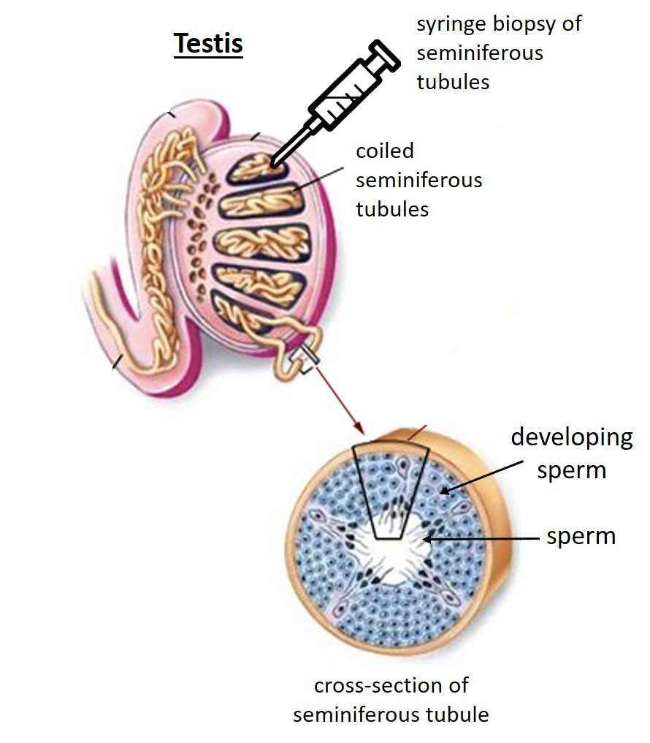

The matters ACART has considered

Overview of the legal and ethical matters
    - It is standard practice by fertility clinics to use CTT to extract sperm which are then used to create embryos.
    - Ethically, there are few concerns other than usual clinical matters for the person from whom the tissue will be retrieved, and any ethical concerns that arise if the testicular tissue is to be donated to a third party.
    - ACART believes that men who have had testicular tissue frozen should be able to donate the tissue/sperm to other people, for extracting sperm to use in fertility treatment or for research, just as they would with standard sperm donation (eg, frozen from ejaculated semen). This is consistent with other forms of sperm donation. It is unlikely that tissue grafting (transferring tissue from one individual to another) would be clinically effective or permitted in donation scenarios. ACART does not consider the ethical issues in the use of sperm obtained from thawed testicular tissue to be any greater than in the use of sperm from fresh tissue or ejaculated semen.
    - The legal issue to consider is the absence of this tissue type being included in the Order, as part of any EPs, to use sperm for insemination or egg fertilisation in vitro. Cryopreserved ovarian tissue is mentioned in the Order and it seems sensible to ensure CTT is included, to avoid doubt as to its legal status.

Cultural considerations
    - New Zealand is a culturally and ethnically diverse country, and ACART has taken this into account when addressing this matter. Principle 4(g) of the HART Act requires different ethical, spiritual and cultural perspectives to be considered and treated with respect in the context of assisted reproduction.
    - People of diverse ethnic groups, including Māori and Pacific peoples, use fertility treatment, and services should be provided in culturally acceptable ways for all people. Submitters may share their cultural perspectives on the use of CTT and ACART will take them into account during the consultation.
    - ACART’s position generally on cultural matters is set out in full in the online document about its functions and the regulatory and ethical setting.

Disability perspective
    - When developing guidelines or advice, ACART must consider the perspectives of people with disabilities. This consideration is also set out in the online document. For men who have suffered spinal injuries, the procedure and use of CTT is common to preserve their reproductive options.

International practice
    - The United Kingdom, Canada and Victoria, Australia, all regulate the use of CTT. Ethical review is not required in Victoria, Australia. There, clinicians do not have to obtain permission from an ethics committee or authority to use the tissue; rather, they rely on their clinical judgement.
    - The UK uses licensing of clinics to ensure that the retrieval, storage and use of testicular tissue for fertility treatment is done safely and ethically.

Proposed change to the HART Order

Proposal and rationale for change
    - ACART’s position on the cryopreservation and use of testicular tissue is that:
- CTT should sit within the existing EP of sperm preservation
- the use of sperm from thawed testicular tissue falls within IVF and ICSI or other EPs, unless the sperm is used in an assisted reproductive procedure (one that must be considered by ECART) or research
- the HART Order needs to be amended to specifically state that the common practice of retrieval and use of CTT is an EP.
    - By amending the HART Order, clinics will be able to use the tissue, as they are now, with the certainty that they do not need to seek ECART approval.
    - ACART notes that, if this change to state that CTT is an established procedure is accepted, the proposal would need to be agreed by the Minister of Health and by Cabinet.
    - The exact wording of the Order would be drafted by the Parliamentary Council Office. They would liaise with Health Legal and ACART to ensure the wording is suitable.
    - This minor amendment could be processed along with other pending proposed changes to the HART Order, such as the changes proposed with the revised Donation and Surrogacy Guidelines.

Storage provisions
ACART has considered the issue of storage for CTT and notes that if an individual requires testicular tissue to be retrieved and frozen for fertility preservation, the 10-year storage provision in the HART legislation may not be sufficient. ACART discussed whether this document could propose a change to the storage provision but concluded that enacting separate storage periods for frozen tissue is not necessary when there is already the option to extend storage through an application to ECART.

How to have your say
Your feedback is important to help ACART develop its advice to the Minister of Health.

Please take this opportunity to have your say. There is a feedback form on page 8. You may give individual feedback or as a member of an organisation. You can contribute your views in one of these ways.
1. Complete the Citizen Space link through the Ministry of Health’s website.
2. Email a completed feedback form or your comments to acart@moh.govt.nz.
3. Post a completed feedback form or your comments to:
ACART Secretariat
PO Box 5013
Wellington.

ACART welcomes your views on any of the issues raised. Please state if you wish to make an oral submission, which we will support through video or teleconference.

Publication of feedback
We may publish all submissions, or a summary of submissions on the Ministry of Health’s website.

Official Information Act requests
In accordance with guidance from the Ombudsman, the Ministry’s standard procedure is to not release the name and contact details of a submitter who has given personal feedback (not in a professional capacity or on behalf of an organisation) and who has requested that the information not be published by ticking the relevant boxes on the feedback form.

If a person has given feedback on behalf of an organisation, the Ministry will release the name and contact details of the submitter and the organisation unless there are other reasons for withholding the information under the Official Information Act. If you consider that we should withhold your or your organisation’s name and/or contact details under the Act, please make this clear on your feedback form, noting the reasons.

Further guidance on releasing information under the Official Information Act is available at www.ombudsman.parliament.nz/resources-and-publications.

The closing date for feedback is 30 July 2021.

Feedback form
Please provide your contact details below.
Name
If this feedback is on behalf of an organisation, please name the organisation
Please provide a brief description of the organisation (if applicable)
Address/email
Interest in this topic (eg, user of fertility services, health professional, researcher, member of public)

Would you like to make a verbal submission in addition to the written submission?
Yes No (Note that this is likely to be done by video or teleconference.)

Are you?
Male Female I identify in another way

Which of the following age groups do you belong to?
13–19 years 20–24 years 25–34 years 35–44 years
45–54 years 55–64 years 65–74 years 75+ years

What is your ethnicity? (tick all you identify with)
NZ European Māori Pacific peoples
Asian Other

Privacy
We may publish all submissions, or a summary of submissions on the Ministry of Health’s website. If you are submitting as an individual, we will automatically remove your personal details and any identifiable information. You can also choose to have your personal details withheld if your submission is requested under the Official Information Act 1982.

If you do not want your submission published on the Ministry’s website, please tick this box:
Do not publish this submission.

Your submission will be subject to requests made under the Official Information Act. If you want your personal details removed from your submission, please tick this box:
Remove my personal details from responses to Official Information Act requests.

If your submission contains commercially sensitive information that you do not wish to be released, please tick this box:
This submission contains commercially sensitive information.

Question 1
Should the HART Order be amended to state that the use of CTT is an established procedure?
 | Yes |  | No
Comments

Question 2
Do you have any other considerations about the use/s of CTT that you think are important for this consultation?
 | Yes |  | No
Comments

Glossary
This glossary is a list of terms used throughout this document. It does not present technical definitions.
Advisory Committee on Assisted Reproductive Technology (ACART) | The advisory committee established under New Zealand’s Human Assisted Reproductive Technology Act. The Minister appoints members. See www.acart.health.govt.nz.
Assisted reproductive procedure | The Human Assisted Reproductive Technology Act defines an assisted reproductive procedure as a procedure performed for the purpose of assisting human reproduction that involves:  - the creation of an in vitro human embryo, or  - the storage, manipulation or use of an in vitro human gamete or an in vitro human embryo, or  - the use of cells derived from an in vitro embryo, or  - the implantation into a human being of human gametes or human embryos; but  - does not include an established procedure.
Cryopreservation | The process of freezing and storing cells, gametes and embryos at very low temperatures to maintain their viability when thawed for use. Typically, storage is in liquid nitrogen at -196°C.
Donation | The giving of gametes or embryos for reproductive purposes.
Ethics Committee on Assisted Reproductive Technology (ECART) | The ethics committee established under the HART Act. On a case-by-case basis, ECART reviews and decides applications to undertake assisted reproductive procedures and human reproductive research, and to extend the statutory storage period of gametes and embryos. The Minister of Health appoints members. See www.ecart.health.govt.nz.
Established procedure | A procedure declared in the HART Order that does not require ECART review and approval. See section 6 of the HART Act.
Gamete | An egg or sperm, whether mature or not, or any other cell (whether naturally occurring or artificially formed or modified) that contains only one copy of all or most chromosomes and is capable of being used for reproductive purposes.
Human Assisted Reproductive Technology (HART) legislation | The Human Assisted Reproductive Technology Act 2004 and Human Assisted Reproductive Technology Order 2005.
Human reproductive research | Defined in the HART Act as research that uses or creates a human gamete, a human embryo or a hybrid embryo.
Surrogacy | The process whereby a woman becomes pregnant, carries and delivers a child on behalf of another person or couple (the intended parent/s).
Surrogacy guidelines | Guidelines issued by ACART relating to surrogacy – currently the Guidelines for family gamete donation, embryo donation, the use of donated eggs with donated sperm and clinic assisted surrogacy.

References
ACART. 2020. Summaries of the regulation of assisted reproduction in New Zealand and the legal, ethical and cultural issues often involved in assisted reproduction.
Testis image modified from https://www.philpoteducation.com/mod/book/view.php?id=814&chapterid=1094#/

The procedures are not included in the HART Order. In contrast, it addresses cryopreserved ovarian tissue in Part 1 and Part 2.
https://acart.health.govt.nz/summaries-regulation-assisted-reproduction-new-zealand-and-legal-ethical-and-cultural-issues-often
https://acart.health.govt.nz/summaries-regulation-assisted-reproduction-new-zealand-and-legal-ethical-and-cultural-issues-often
https://acart.health.govt.nz/summaries-regulation-assisted-reproduction-new-zealand-and-legal-ethical-and-cultural-issues-often
https://acart.health.govt.nz/consultations/past-consultations/second-round-consultation-proposed-donation-and-surrogacy
https://acart.health.govt.nz/publications-and-resources/guidelines-and-advice-issued-ecart

